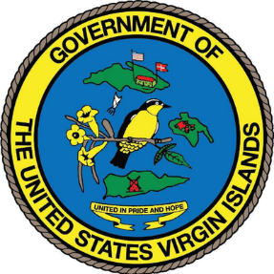
GOVERNMENT OF THE VIRGIN ISLANDS OF THE UNITED STATES
--------0--------
DEPARTMENT OF PLANNING AND NATURAL RESOURCES
4611 Tutu Park Mall 45 Mars Hill, Frederiksted
Suite 300 St. Croix, VI 00840
St. Thomas, VI 00802 (340) 773-1082
(340) 774-3320 dpnr.vi.gov

Office of the Commissioner

CONTACT: Jamal Nielsen, Media Relations Coordinator
jamal.nielsen@dpnr.vi.gov

Friday, March 21, 2025

FOR IMMEDIATE RELEASE

BEACH ADVISORY

The Department of Planning and Natural Resources (DPNR) announces that the Beach Water Quality Monitoring Program, which evaluates weekly water quality at popular swimming beaches throughout the Territory by sampling for Enterococci Bacteria and Turbidity, which is a measure of water clarity, advises the public of the following:

DPNR performed water quality analyses at 20 designated beaches throughout the Territory during the week of March 17– March 21, 2025.

Based on the analytical results, the following beaches met water quality standards and are considered safe for swimming and fishing:

St. Croix
Buccaneer Beach | Gentle Winds | Rainbow Beach
Cane Bay | Grapetree Bay | Shoy’s Beach
Chenay Bay | Ha’Penny Beach | Stony Ground
Cramers Park | New Fort Louisa Augusta
Dorsch Beach | Pelican Cove (Comorant)
Frederiksted Public Beach | Princess Condo Row

St. John
Cruz Bay
Frank Bay
Great Cruz Bay
Johnson Bay
Oppenheimer Beach

Please note: Samples were not collected at the following beaches.

- Protestant Cay on St. Croix
- All the beaches on St. Thomas
- Honeymooon Beach (Druif) on Water Island

Therefore, the water quality at these beaches is unknown.
Please be advised that anyone swimming in sewage-impacted or stormwater-impacted areas may be at an elevated health risk because of increased concentrations of bacteria or other contaminants. Areas impacted by sewage, stormwater runoff (i.e., guts, puddles, and drainage basins), or any area that appears discolored or has foul odors should be avoided. DPNR will continue to monitor impacted areas and waters.
For additional information regarding water quality, call the Division of Environmental Protection at 773-1082 in St. Croix or 774-3320 in St. Thomas.

